**"CO2 close to lowest levels ever for our planet"**

**So why are we spending billions on renewables that can never be cost effective?**

**THESE CLIMATE CHANGE GRAPHS – SHOW HOW IT REALLY WORKS**

**If you follow the graphs and understand their direction – the end will astonish you.**

**Here are the graphs used to ‘prove’ Climate Change and that increased CO2 is a major problem that we must urgently deal with to save our planet.**

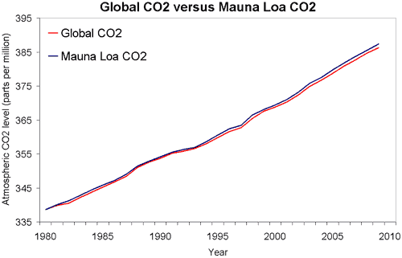

Figure 2: Global atmospheric *CO2* ([*NOAA*](http://www.esrl.noaa.gov/gmd/ccgg/trends/#global)) versus Mauna Loa *CO2* ([*NOAA*](http://www.esrl.noaa.gov/gmd/ccgg/trends/)).

<https://skepticalscience.com/co2-measurements-uncertainty.htm>

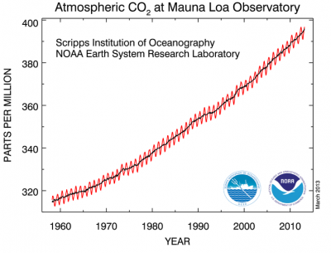https://www.esrl.noaa.gov/gmd/ccgg/trends/global.html



<http://cdiac.ess-dive.lbl.gov/trends/co2/graphics/South_Pole_CO2.jpg>

**Starting at 1960 CO2 looks like it is very low. But skyrocketing to the top RH corner, it looks alarming.**

**These graphs show how undeniable this grave situation is to mankind and our planet must be saved.**

**There is only one major problem with all of the graphs used as supportive evidence.**

**Do you identify what it is?**

**Did you look carefully at the graph and read it or did you only see the rising red line?**

**NONE start at zero Parts Per Million.**

**They all start above 300 ppm—Why?**

**Look at the bottom LH side they do not start at zero, they start at 320 ppm and go up to 400 ppm, what you are actually looking at is a very small section zoomed in to create an enlarged panic effect.**

**If they started further back in time you would have seen that today’s levels are well below the levels of past times and are some of the lowest on record.**

**As on the official graph sourced from the Intergovernmental Panel on Climate Change (IPCC) and the US Government National Oceanic and Atmosphere Administration (NOAA) clearly shows CO2 nearly 8,000 ppm 520 million years ago—the graph is further down.**

**The following graph shows atmospheric CO2 levels over the last 10,000 years. It includes ice core data for CO2 levels before 1950. For values after 1950, direct measurements from Mauna Loa, Hawaii were used.**

https://skepticalscience.com/co2-measurements-uncertainty.htm

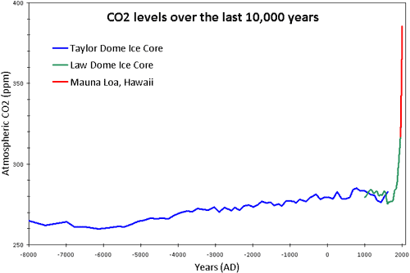

http://myrenaultzoe.com/index.php/2013/05/remember-today-earths-co2-level-passes-400-ppm/

**Here is what they want you to see and be alarmed about—look at the terrible rise in CO2.**

**The chart does not start at Zero to deliberately mislead you.**

**A great alarmist’s tool to deliberately mislead and deceive your thinking.**

**Look where the graph line started at 265 ppm on the bottom LH corner and finished at 380 ppm on the RH corner. A rise of 115 ppm is a very minor movement on a global history scale where it has been up to 8,000 ppm**.

Temperature and Carbon Dioxide Concentrations from 1880 to present.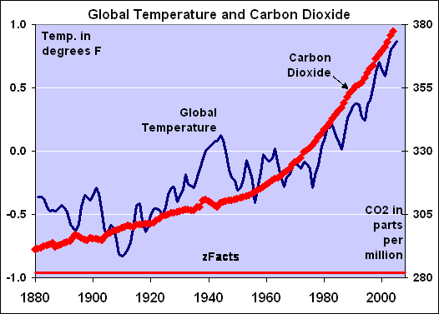

https://wattsupwiththat.com/2010/06/09/a-study-the-temperature-rise-has-caused-the-co2-increase-not-the-other-way-around/

**See the same alarming rise in CO2 except the graph line does not start at zero, it starts near 300 ppm—similar to the previous graphs.**

**People are deliberately mislead and confused about the rate of increase of carbon dioxide. People are directed to think that CO2 is rising dramatically because of graphs like the one below.**

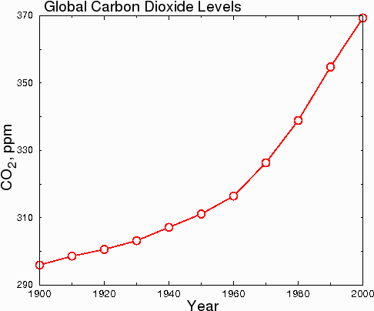   
Graphs and data from: <http://www.randombio.com/co2.html>

In hard science journals, the graph above would be considered dishonest, because the y-axis starts at 290 instead of zero. This misleads the reader into thinking that CO2 levels have undergone a huge increase when in fact, CO2 levels have only increased by 23.7% or since 1900. When the data are plotted honestly, with the y-axis starting at zero, the true minor scope of the 380 ppm change becomes clear.

According to the US Department of Energy, about 14.8% of the total CO2 is man-made. The remainder is caused by natural forces, such as volcanoes and forest fires.

At the current rate of increase, CO2 will not double its current level until 2255. At 760 ppm it would still be within earth’s normal range, in the last 300 million years the average level of atmospheric CO2 was approximately 1200 ppm.

Fanatical climatologists and alarmists have used trickery and gross exaggeration to justify their doomsday nonsense and create a political issue costing millions of wasted dollars and extreme hardship on many people. The lack of discernment and analytical ability has created a fanatical ‘Climatology’ religion (Scientology) by so many unable to understand the frailty of their thinking.

The gross embarrassment to the people of the world is many elected representatives are so gullibly stupid they failed to do simple research and analyse the hoax used by many to make millions from renewables.

Their nativity and lack of analyses has wasted billion on renewables and forced electricity cost to unaffordable levels with devastating results upon many families and business.

**All the above if graphed correctly would look like these two below.**

[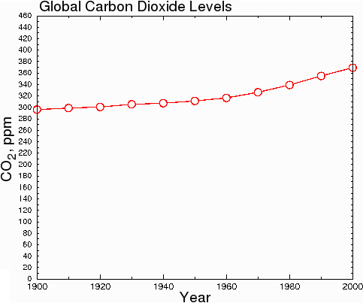](http://www.google.com.au/url?sa=i&rct=j&q=&esrc=s&source=images&cd=&cad=rja&uact=8&ved=0ahUKEwjAtN31weLWAhXFvrwKHQ8IAb8QjRwIBw&url=http://www.randombio.com/co2.html&psig=AOvVaw0M8OiyEGracekXA5bMCaA1&ust=1507603219289335)

http://www.randombio.com/co2.html

The virtical axis starts at zero

Maunaloa.co2.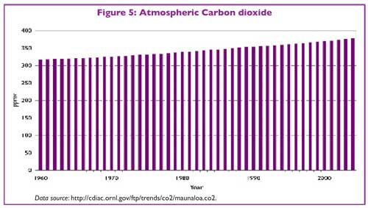

**Measurements taken at Mauna Loa in Hawaii**

[**http://cdiac.ess-dive.lbl.gov/trends/co2/recent_mauna_loa_co2.html**](http://cdiac.ess-dive.lbl.gov/trends/co2/recent_mauna_loa_co2.html)

**The two graphs above start at zero ppm showing the CO2 rise is not alarming at all**

**Think maybe you have been seriously mislead and deceived?**

**Historic climatic fluctuations show we are still within the normal range**

[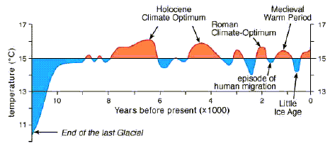](http://www.google.com.au/url?sa=i&rct=j&q=&esrc=s&source=images&cd=&ved=0ahUKEwjj4cz04OnWAhWJy7wKHbh8CGYQjRwIBw&url=http://isthereglobalcooling.com/&psig=AOvVaw3PCwu8wR8YIATsOykhdgYy&ust=1507852050318431)

<https://www.iceagenow.info/global-warming-%E2%80%9Cunprecedented/>

**Carbon Dioxide is the lowest in 600 million years. Plants flourish best at 1,200 ppm, which is the average level of the last 300 million years.**

**THE COMPARISON OF HISTORICAL ATMOSPHERIC CO2 GRAPH**

**This chart below was sourced from the Intergovernmental Panel On Climate Change (IPCC) and the US Government National Oceanic and Atmosphere Administration (NOAA).**

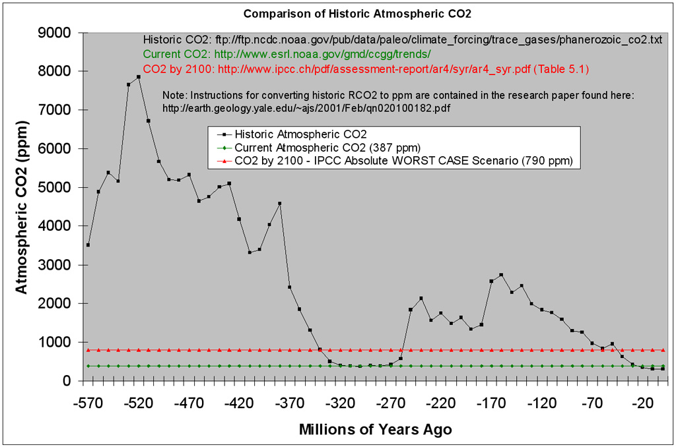

<http://www.use-due-diligence-on-climate.org/home/climate-change/greenhouse-gases/co2-for-plants/>

**Now let’s zoom out and look at the entire full big picture where we can see the entire time-line from 570 million years ago to the present day, this’ official chart’ sourced from the IPCC and NOAA show the CO2 was actually almost 8,000 ppm roughly 520 million years ago, all before the industrial revolution and before humans, and this chart is honest as it starts at zero ppm in the bottom LH corner. So how did it get to that point long before humans, clearly the planet did it all by itself.**

**In fact if you understand the BIG picture look at the bottom RH corner and you see the CO2 is near the lowest it has ever been in this time period for which we have data. Now you see why the climate change alarmists do not want to show you this graph, for the ‘dot’ in the bottom RH corner represents the present CO2 that we know.**

**This IPCC graph clearly shows that CO2 was actually 8,000 ppm roughly 520 million years ago and from 1,000 to 5,000 ppm are normal fluctuations.**

**As you can see here CO2 levels have been much, much higher in the past, not just 2,000 ppm or 5,000 ppm but 7,000 and 8,000 ppm which all happened long before the industrial revolution, there were no fossil fuels being burned by humans 520 m years ago.**

**So if Global warming is caused by humans how did CO2 get to almost 8,000 ppm 520 M years ago**?

**Note: The vertical axis (RH bottom corner) of this chart starts at zero so you can see the entire big picture, you can see where CO2 levels have been before and where they are now, the more you see of the big picture you can see the CO2 levels now are at almost the very lowest level they have ever been in the known history of our planet.**

**CO2 almost at the lowest level ever recorded for our planet.**

**The Climate change alarmist will never show you this factual history, they only want to show you their selected section of the chart that never starts at zero and present a false picture from 1960 to the present or their other one from 1750 to today but they will never show you the entire big chart we have just been looking at, from 570 million years ago to the present, because that chart shows human activity could not possibly be the only cause of CO2.**

[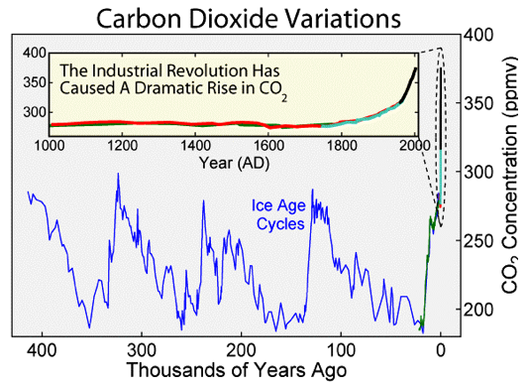](https://www.google.com.au/url?sa=i&rct=j&q=&esrc=s&source=images&cd=&ved=0ahUKEwjFu5qziefWAhUKNbwKHRCQAx0QjRwIBw&url=https://www.e-education.psu.edu/earth103/node/1018&psig=AOvVaw3i5HWAHDlHsy6lZxM0B97A&ust=1507759876624687)

**Starting at 200 ppm**

https://www.google.com.au/url?sa=i&rct=j&q=&esrc=s&source=images&cd=&cad=rja&uact=8&ved=0ahUKEwjh5KTnmPHWAhWDwLwKHeI_BgoQjRwIBw&url=https%3A%2F%2Fen.wikipedia.org%2Fwiki%2FCarbon_dioxide_in_Earth%2527s_atmosphere&psig=AOvVaw0SFzhWSbxbGssJ3k4575_T&ust=1508105178402964

<https://scripps.ucsd.edu/programs/keelingcurve/co2-graphs/>

**Now let’s go back 400,000 years and look at this chart called ‘Carbon Dioxide Variations’ in large view it show CO2 has been cycling between 200 and 500 ppm or hundreds of thousands of years now they say the industrial revolution has caused this dramatic rise, it has gone from roughly 265 up to 380 ppm = a 115 ppm very minor undramatic rise.**

**This looks very alarming but they don’t show a vertical axis zero base, it starts at 200 and goes to 400 they are only showing you selected parts of the overall graph purely based on trickery. They know they can mislead and fool most of the people most of the time—but cannot fool all of the people all of the time. It is surprising to see how many they fooled—were you one of them?**

* [**Climate change is the norm**](https://youtu.be/RkdbSxyXftc)**al function of the Earth engine. Never in the 800,000-year ice core record has climate not been changing.**
* **Four Temperature Peaks in the last 400,000 years were all above today’s temperatures and occurred at lower CO2 levels.**
* **Every ice-age began when CO2 was at or near peak levels, in other words, high CO2 levels were not enough to prevent ice ages.**
* **The current record high level of 400 parts per million (ppm) CO2, a full 33% above any previous level on the chart, has failed to carry temperatures to a record high.**
* **For any** [**cause and effect relationship**](https://youtu.be/QowL2BiGK7o?t=4m11s)**, the cause MUST lead the effect.** [**CO2 does not lead Temperature**](https://youtu.be/QowL2BiGK7o?t=17m2s)**, it follows it by 800 to 1,500 years.**

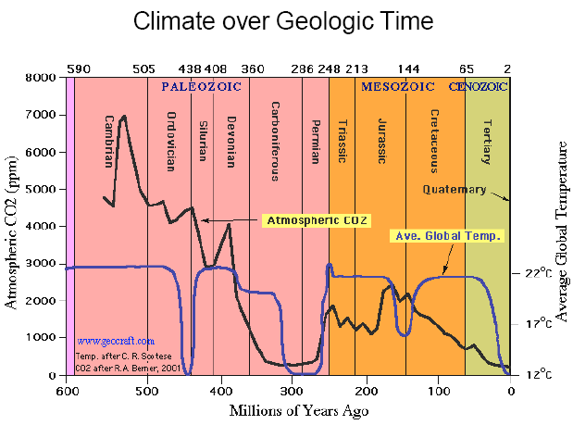

Current temperature

[**https://wattsupwiththat.com/2015/05/09/plants-encouraged-as-co2-levels-reach-400-ppm/**](https://wattsupwiththat.com/2015/05/09/plants-encouraged-as-co2-levels-reach-400-ppm/)

**http://deforestation.geologist-1011.net/**

**Later Carboniferous to Early Permian time (315 mya – 270 mya) is the only time period in the last 600 million years when both atmospheric CO2 and temperatures were as low as they are today (Quaternary Period).** CO2 after Berner (2001) & temperature after Scotese (2001; see also Boucot et al., 2004) sourced from [*www.geocraft.com*](http://www.geocraft.com) showing the degree of variation in carbon dioxide throughout geological history.

**FACTS:**

**The current CO2 level of 380 ppm is at the extreme low end of the past 600 million years. Plants and therefore most life will die if CO2 falls below 180 ppm. Plants thrive at 1,200 ppm.**

**Most plants, especially the** [**complex vascular plants**](http://www.encyclopedia.com/topic/Evolution_of_Plants.aspx) **evolved in the last 300 million years. The average level of atmospheric CO2 over that period was approximately 1200 ppm.**

[**CO2 has been as high at 7,000 ppm**](https://youtu.be/QowL2BiGK7o?t=18m14s)**, or 17.5x today’s level and the earth has NEVER in 600 million years experienced catastrophic global warming, NEVER.**

**Modern reefs and sea life** [**developed over the past 220 million years**](http://www.columbia.edu/itc/eeeb/baker/N0316/Lecture%205/page2.htm)**when CO2 and temperatures were much higher than today. Coral Reefs only exist in the warm parts of the oceans and rely on** [**dissolved CO2 to form their CaCO3 shells**](http://www.coral-reef-info.com/coral-reef-formation.html)**.**

**Over the past 600 million years, CO2 and Temperature simply aren’t correlated, and regardless of the level of CO2, temperatures cap out around 22 Degrees C.**

**CO2 caused ocean acidification is simply not a possibility due to the huge** [**buffering capabilities of the ocean**](https://youtu.be/iEPW_P7GVB8)**, once again, the coral reefs developed during periods of much higher CO2 levels.**

**The current CO2 of 380 ppm is the lowest it has ever been.**

**CO2 has almost nothing to do with average global temperatures. The average global temperature has cycled between 12 c between 22 c several times in the last few hundred million years. The bottom RH corner shows you the average global temperature today.**

**The temperature changes are driven by global events, volcanoes, the sun and celestial events.**

**For most of Earth's history carbon dioxide levels in the atmosphere have been much much higher than in the modern era (pre-industrial). Dropping to current levels only a few million years ago in the Neogene. For most of Earth's history CO2 levels have been 6 to 10 times what they are today (post Cambrian). Levels in the Cretaceous were 6 times today's levels.**

**It is volcanic activity and solar influences that control our weather and temperature changes, CO2 has nothing whatsoever to do with it.**

**The truth is in this paper for all to read—the lies and deceit have come to an end, sadly many politicians were sucked in by the plausible distortions and wasted many millions on renewables and now have the nation in a serious power shortage that requires immediate expenditure on new modern, highly efficient and clean coal fired power stations.**

**For years the ‘Climate Alarmists’ or ‘History Deniers’ have been quoting claimed ‘official graphs and statistics’, BUT only showing a very small piece of the graph enlarged to make it seem as part of the big-picture. When the full graph is shown the BIG LIE becomes very evident by deceit, sadly this lie has been quoted in parliaments across the world, so the protagonists should be tacked down and all charged with misleading parliament and attempting to mislead and pervert the course of justice costing our nation billions devastating our power generation and damaging industry and household budgets.**

**Many Australian Politicians and the Press ravenously grabbed these lies and distortions with glee as supportive material for their crusade, never once checking the facts supplied and went on to deliberately mislead parliament and the nation by presenting these quotes and figures as being factual. There needs to be full parliamentary inquiry to identify and remove those who deliberately mislead and insulted our parliament and out nation with these lies.**

**As Lord Keynes famously said, "When the facts change, I change my mind. What do you do, Sir?"**

**Climate Change Alarmists worked by using half-truths like a half-brick, they could throw it further and it hit harder—now they have been exposed.**

**The truth is in the above pages for all to read—the lies and deceit have come to an end.**

**Sadly many politicians were sucked in by the plausible distortions and wasted many millions on renewables and now have the nation in a serious power shortage that requires immediate expenditure on new modern, highly efficient and clean coal fired power stations.**

**CARBON TRADING CREDITS**

**Global Warming—Now Morphed To—Climate Change**

**Remember a few years ago in many shopping centres, outside country stores and in streets there were people at a stall giving away FREE energy efficient showerheads and light bulbs. The bulbs were the twisted glass tube mercury vapour type. Before they gave you FREE shower heads and light bulbs you had to fill out a form or they filled it out for you and you signed it to get your ‘freebies’. Very few were interested or cluey enough to read the document they signed, what they had done was irrevocably signed away the carbon credits to their home and property owned by them—forever. It would have taken a Supreme Court judgment if you were lucky to revoke it.**

**Many land owners were approached with puny offers to sign-over their carbon credits, including the writer and I was made a lucrative offer to approach other landowners to get them to sign-over their carbon credits.**

**There was a massive amount of business structuring to be able to take over as much carbon credits from whatever source as possible, they were so sure it would become legislation and they had a lead-time to the legislation to get their structure in place. Thus they would have made millions in a very short time-frame once a Carbon-Credit Trading System was implemented—this was a multi-million dollar project.**

**How many MP’s had or have investment that could benefit from carbon credits and trading—a full investigation is needed. Such might show why public funds were wasted on carbon trading legislation?**

All Climate Change graphs and data were easily back-searched on the internet showing the alarmist’s hoax when compared against factual historic data from US Government and IPCC sources.

From the office of: G J May

Retired: Administrator:

Marriage Celebrant: Funeral Celebrant: JP

First Class Steam Engine Driver & Farmer

>[gilmay97@gmail.com<](mailto:gilmay97@gmail.com%3c)

16 October 2017